# Police intelligence has suggested for some time that Mr Matthew Boyle is involved in drug distribution in Portsmouth particularly in the Southsea area. Mr Matthew Boyle worked as a DJ in Portsmouth clubs during his undergraduate studies and he has continued to keep close links with venues such as pubs and clubs where young people congregate. Mr Matthew Boyle, born on the 4th of October 1992 and known as Mat, is originally from the Greater Manchester Area. He moved to Portsmouth to study for a BA degree in Art and Music in the school of Creative Technology.

# According to a police interview and records, he received an inheritance in 2009 from his grandmother and spent it on buying flats to rent to students. He himself lives in his own flat, in SOUTHSEA PORTSMOUTH flat 23, block 2, level 3, and rents some of its rooms to students. He has a girlfriend called Samantha who is 21 years old and studies at Portsmouth University doing a BSc in Chemistry. She also has a brother, Alexander, who studies computer science in the school of computing. The interview of the police indicated that Alexander and Matthew are not on good terms. Matthew has a flirting nature with girls and Alexander, being the brother of Samantha, disapproves of it. In general, Mr Matthew Boyle describes himself as a ‘record producer’ and ‘talent-spotter’ and has an office in his flat, which may be being used as a front for money laundering from illegitimate income such as drugs. His girlfriend sometimes stays at his flat and she has full access to his computers and office according to information from the police interview record.

# Mr Boyle became a suspect to the Hampshire Drug Offences Unit when they received reliable intelligence from Manchester Crime Unit after the arrest of a drug dealer, named Anthony Dealer, who had the phone number of Mr Matthew Boyle in his contact list. Mr Anthony Dealer admitted to the police during the interview that he is a close friend of Mr Matthew Boyle. Mr Matthew Boyle does not have a criminal record. However, the police believe he is a supplier of class A drugs, predominantly Ecstasy tabs, and class B drugs, Cannabis Resin. Mr Matthew Boyle’s premises have been put under surveillance for several weeks. The intelligence source, after watching the movement of Mr Matthew Boyle, suggested that he might have more connections in the Greater Manchester area than first thought, such as meeting people in pubs and clubs for possible drug distribution.

# Furthermore, the surveillance source revealed that he lived on his own and his girlfriend sometimes stays at his place on the weekends. He also appears to receive regular visits from a much younger woman,believed to be a student or a relative of one of his tenants, Jack. Mr Boyle regularly attends pubs, clubs and events in Southsea where it is believed that drugs are being sold. On Tuesday the 29th of October, after an anonymous phone call to Hampshire Crime Unit regarding Mr Matthew Boyle’s behaviour, the intelligence source believed that he might be in possession and production of indecent material related to child pornography. There were some suggestions that an unidentified younger woman visiting Mr Boyle’s flat may be underage too. The Senior Investigating Officer, DCI Holmes, obtained a search warrant, then immediately raided Mr Boyle’s flat and office, and arrested him under the Police and Criminal Evidence Act, Section 17, 18 & 19, which was authorised, and took place on the 8th of November 2022 at 15:00 hours.

**Potential charges**

Three counts of possession of illegal substances (Misuse of Drugs Act 1971)

Class A drugs (up to seven years in prison)

Class B drugs (up to five years in prison)

Class C drugs (up to 2 years in prison)

Three counts of possession of illegal substances with an intent to distribution (Misuse of Drugs Act 1971 (section 5(3))

Class A drugs (up to life in prison)

Class B drugs (up to fourteen years in prison)

Class C drugs (up to fourteen years in prison)

Two counts under the Sexual Offences Act 2003

Causing or inciting child prostitution or pornography (14 years)

Sexual activity with a child (14 years)

Relates to -- Ref No: pending

Location / Venue pending Date of Offence pending

Forensic Case Ref: pending Crime No: pending

Forensic Lab Ref: pending Examiner/Role/ pending

Custody/URN: pending Report No: ----1-----

2.1 Case management – To the court and to the defence: The prosecution proposes to rely on the forensic evidence contained in this SFR and if there is a trial, to adduce it by way of a s10 CJA 1967 admission to the general effect that the exhibit(s) listed were forensically examined and the examination produced the result(s) described. Therefore, should there be a real issue in relation to the forensic evidence below, such that the admission cannot be made, the prosecution asks that the defence identify the issue (Crim.PR.3.3 and Crim.PR 33.3(2)). If this report contains expert evidence, then, in accordance with CPR 33.3(2), the defence is required to serve a response to this report as soon as practicable, and in any event not more than 14 days after service of the report setting out which, if any of the conclusions in this report are admitted as fact, and where a conclusion is not admitted what are the disputed issues concerning that conclusion. This SFR is not a witness statement to which the provisions of s9 CJA 1967 and Crim.PR 27 apply, nor is it an expert’s report to which the provisions of Crim. PR 33.4 applies, its purpose being to introduce any expert evidence contained therein as admitted fact. If this SFR contains expert opinion, it is a

summary of that opinion served pursuant to Crim. PR 33.3(1). SFRs assist courts to fulfil their duty to manage the case (Crim.PR 3.1) by ensuring that evidence is presented in the shortest and clearest way and by facilitating the early identification of the real issues. (CrimPR 3.2). Each party must actively assist the court in fulfilling its duty (CrimPR 3.3).

**Forensic evidence/s**

| Exhibit | Number |
| --- | --- |
| TomTom Go 950.xry | 1 |
| Huawei nexus 6p A2 TD-LTE H1512 | 2 |
| Mathew-windows-xp.vdi | 3 |
| matthew.dd | 4 |
| Matthew.vdi | 5 |
| Matthew and samantha emails | 6 |

**Extraction report**

| **Device info/devices** | Huawei nexus 6p A2 TD-LTE H1512 | TomTom Go 950.xry |
| --- | --- | --- |
| Device name | Huawei nexus 6p A2 TD-LTE H1512 | TomTom Go 950.xry |
| Device serial number |  | WB1488K01270 |
| Device uniqueID |  | AKVHA BSE6N |
| Current map version |  | 810.1934 |
| Current map |  | Western_and_Central_Europe |
| Subscriber id | 234262011348371 |  |
| Iccid | 8944260907113483715 |  |
| Imei | 867982021829511 |  |
| Manufacturer | google |  |
| Service provider name | lycamobile |  |

# 

# **Drug distribution case**

**Solid evidence Drug distribution table**

| Device artefact | Web search | Visit count | Visit date |
| --- | --- | --- | --- |
| Mathew-windows-xp.vdi | How to make meth | 1 | 27/09/2019 |
| Mathew-windows-xp.vdi | How to make meth | 1 | 27/09/2019 |
| Mathew-windows-xp.vdi | How to make meth | 1 | 27/09/2019 |
| Mathew-windows-xp.vdi | How to sell drugs on dark web | 1 | 27/09/2019 |
| Mathew-windows-xp.vdi | How ti cut cocaine | 1 | 27/09/2019 |
| Mathew-windows-xp.vdi | How criminals exploit the dark net to sell drugs | 1 | 27/09/2019 |
| Mathew-windows-xp.vdi | How criminals exploit the dark net to sell drugs | 1 | 27/09/2019 |
| Mathew-windows-xp.vdi | Hoe to make cocaine | 1 | 27/09/2019 |
| Mathew-windows-xp.vdi | How to cut cocaine dangers of cocaine cutting agents | 1 | 27/09/2019 |
| Mathew-windows-xp.vdi | How to cut cocaine dangers of cocaine cutting agents how to cut cocaine dangers of cocaine cutting agents | 1 | 27/09/2019 |
| Mathew-windows-xp.vdi | How is cocaine made?  From plant to illegal product | 1 | 27/09/2019 |

In the Solid evidence Drug distribution table,a total of 11 searches were found on the Mathew-windows-xp.vdi file where the suspect had enquired about how to make and sell class A drugs such as cocaine and meth. They even enquired on how to sell it on the dark web which is an underground market place where illegal activity is a regular occurance. These searches were obtained through analysing the search history file of the Mathew-windows-xp.vdi. Forensic toolkit 7.6.0 was used to analyse the Mathew-windows-xp.vdi file. An image was made from the Mathew-windows-xp.vdi so that the original evidence would not be tampered with.

**Substantial drug distribution evidence table**

| Device artefact | name | path | metadata |
| --- | --- | --- | --- |
| TomTom Go 950.xry | locations | locations | 29 locations |
| TomTom Go 950.xry | Deleted files and media | files and media | 15 deleted files and media |
| Huawei nexus 6p A2 TD-LTE H1512 | Tor browser(Alpha) | /data/app/org.torproject.torbrowser_alpha-N_LIH0hHLLf12rwoi5lTNg==/base.apk | Installed:30/05/2019 15:39:33 (Device)  [30/05/2019 14:39:33 UTC]  version:60.8.0  storage : Device |
| Huawei nexus 6p A2 TD-LTE H1512 | Orfox | /data/app/info.guardianproject.orfox-_I2RnvKZDEWRTUl78UnQ-A==/base.apk | Installed: 30/05/2019 15:39:48 (Device)  [30/05/2019 14:39:48 UTC]  30/05/2019 15:39:48 (Device)  [30/05/2019 14:39:48 UTC]  version:Fennec-52.9.0esr/TorBrowser-7.5-1/Orfox-1.5.4-RC-1  storage:device |
| Huawei nexus 6p A2 TD-LTE H1512 | Screenshot_20190604-112919.png  Asked alexa about drugs | /storage/emulated/0/Pictures/Screenshots/ | Type:png  File size:1.01 MB  Storage:device  modified:04/06/2019 11:29:21 (Device)  [04/06/2019 10:29:21 UTC]  Hash(SHA1):fb54b94ae52b3a6e189359b1b5e6db992336581d  dHash Value:008212820a038000 |
| Huawei nexus 6p A2 TD-LTE H1512 | Screenshot_20191204-131728.png  Saying brownies are nice and pizza too | /storage/emulated/0/Pictures/Screenshots/ | Type:png  File size:108.38 KB  Storage:device  modified:04/12/2019 13:17:28 (Device)  [04/12/2019 13:17:28 UTC]  hash (sha1):2a35be3d52b097e9813715991bd732628d1775c5  D hash value:8000000002000000 |
| Huawei nexus 6p A2 TD-LTE H1512 | Screenshot_20191204-131231.png | /storage/emulated/0/Pictures/Screenshots/ | type:Png  File size:1014.57 KB  Storage:device  modified:04/12/2019 13:12:32 (Device)  [04/12/2019 13:12:32 UTC]  hash(sha1):68942a848dc2d83552e43d80a095cca396a48cf9  Dhash value:c08a9a0580804b00 |
| Huawei nexus 6p A2 TD-LTE H1512 | Screenshot_20191204-131553.png  Coin central account details used for cryptocurrency | /storage/emulated/0/Pictures/Screenshots/ | Type:png  File size:178.08 KB  Storage:device  modified:04/12/2019 13:15:54 (Device)  [04/12/2019 13:15:54 UTC]  hash(sha1):6b241fc4c9527f10f8b78032b03cd454280e0ff2  Dhash value:a001000280000000 |
| Huawei nexus 6p A2 TD-LTE H1512 | Screenshot_20191204-131613.png  Email of places.docx being received | /storage/emulated/0/Pictures/Screenshots/ | Type:png  File size:148.04 KB  Storage:device  Modified:04/12/2019 13:16:14 (Device)  [04/12/2019 13:16:14 UTC]  hash(sha1):69ee97bcdf69b90b6c1d14b73bbd1fb8d158a30c  Dhash value:4000800012008100 |
| Huawei nexus 6p A2 TD-LTE H1512 | Screenshot_20191204-131728.png  Tor pdf.docx email | /storage/emulated/0/Pictures/Screenshots/ | Type:png  File size:108.38 KB  Storage:device  modified:04/12/2019 13:17:28 (Device)  [04/12/2019 13:17:28 UTC]  hash(sha1):2a35be3d52b097e9813715991bd732628d1775c5  Dhash value:8000000002000000 |
| Mathew-windows-xp.vdi | Image-1.jpg  ticket | Mathew-windows-xp (1).vdi/Partition 1/NONAME [NTFS]/[root]/Documents and Settings/MAthew/My Documents/Image-1.jpg | Date created  27/09/2019  11:58:32  Date accessed  03/10/2019  20:17:40  Date modified  07/06/2019  MD5 Hash  7acbd2305f0210289408888b46b3c9f1 |
| Mathew-windows-xp.vdi | Boarding pass.jpg | Mathew-windows-xp (1).vdi/Partition 1/NONAME [NTFS]/[root]/Documents and Settings/MAthew/My Documents/Boarding pass.jpg | Date created 27/09/2019  11:58:32  Date accessed  03/10/2019  20:17:43  Date modified  07/06/2019  00:09:02  MD5 hash ef295f68a64689357cf78926aa6a6041 |
| Mathew-windows-xp.vdi | /ketamine-report-annexes.pdf | Mathew-windows-xp (1).vdi/Partition 1/NONAME [NTFS]/[root]/Documents and Settings/MAthew/My Documents/Downloads/ketamine-report-annexes.pdf | Date created 27/09/2019  12:05:21  Date accessed  27/09/2019  12:05:21  Date modified  19/06/2019  05:30:18  MD5 hash 6fef9d8427fbdba98bee6009037247ac |
| Mathew-windows-xp.vdi | IMG_7586.jpg  ticket | Mathew-windows-xp (1).vdi/Partition 1/NONAME [NTFS]/[root]/Documents and Settings/MAthew/My Documents/IMG_7586.jpg | Date created 27/09/2019  11:58:32  Date accessed  03/10/2019  20:17:40  Date modified  07/06/2019  00:05:20  MD5 Hash d32497256153463b259fd7598ecd8d5d |
| Mathew-windows-xp.vdi | IMG_7587.jpg  ticket | Mathew-windows-xp (1).vdi/Partition 1/NONAME [NTFS]/[root]/Documents and Settings/MAthew/My Documents/IMG_7587.jpg | Date created 27/09/2019 11:58:33 (2019-09-27 10:58:33 UTC)  Date accessed 03/10/2019 20:17:40 (2019-10-03 19:17:40 UTC)  Date modified 07/06/2019 00:05:54 (2019-06-06 23:05:54 UTC)  MD5 Hash  1cfb4e83252be81cd9f89fdddbd7a8be |
| Mathew-windows-xp.vdi | travel.docx | Mathew-windows-xp (1).vdi/Partition 1/NONAME [NTFS]/[root]/Documents and Settings/MAthew/My Documents/games/travel.docx | Date created  27/09/2019 11:58:32 (2019-09-27 10:58:32 UTC)  Date accessed  27/09/2019 11:58:32 (2019-09-27 10:58:32 UTC)  Date modified  07/06/2019 00:12:50 (2019-06-06 23:12:50 UTC)  MD5 Hash  7982a3ffb77850735284ad90a22759e7 |
| Mathew-windows-xp.vdi | places.docx | Mathew-windows-xp (1).vdi/Partition 1/NONAME [NTFS]/[root]/Documents and Settings/MAthew/My Documents/places.docx | Date created  27/09/2019 11:58:33 (2019-09-27 10:58:33 UTC)  Date accessed  28/09/2019 10:41:13 (2019-09-28 09:41:13 UTC)  Date modified  19/06/2019 03:55:54 (2019-06-19 02:55:54 UTC)  MD5 Hash  366882be56a07e12f98fb7dc9b52e068 |
| Mathew-windows-xp.vdi | favorites.xlsx | Mathew-windows-xp (1).vdi/Partition 1/NONAME [NTFS]/[root]/Documents and Settings/MAthew/My Documents/My Pictures/Camera Roll/pictures roma/day 1/morning/babe/favorites.xlsx | Date created  27/09/2019 12:06:23 (2019-09-27 11:06:23 UTC)  Date accessed  27/09/2019 12:06:23 (2019-09-27 11:06:23 UTC)  Date modified  06/06/2019 00:44:58 (2019-06-05 23:44:58 UTC)  MD5 Hash  319669f047c7ceda182ea89351f68f6d |

From the Tom Tom device I found 29 different locations that were visited by the owner of the device. There were also travel tickets for Manchester,Portsmouth and southampton. I also discovered that 15 files and media were deleted from the device. However it is unclear what files were deleted. The web browsers Tor and Orfox were installed on the image. These two are privacy browsers which are used to provide a user with anonymity whilst they browse the web. There were images of Mathew discussing brownies and pizza with other contacts he had. There are 3 encrypted files within the image. The places.docx file contained a list of different bars in Manchester along with their address,rating and number of reviews. The travel.docx file was a document detailing the travel costs of the different journeys made. The favourites.xlsx file contained an extortionate menu price for food items such as “pizzA” being £150.

Mathew had asked alexa about drug consumption within the uk in a screenshot. A tor pdf doc was received via email containing different tor links. An extensive report about the drug ketamine was downloaded. Some of these artefacts came from the Huawei nexus 6p A2 TD-LTE H1512. The tool XAMN was used to analyse the contents of the phone. XAMN is a forensic tool that allows you to analyse any mobile device and create reports based on evidence that you find. An image of the Huawei was made and worked on to prevent the original phone from being tampered with. The other artefacts were collected from the Mathew-windows-xp.vdi file.

# **Child pornography case**

**Solid child pornography evidence table**

| Device artefact | name | path | metadata |
| --- | --- | --- | --- |
| Mathew-windows-xp.vdi | dsc01.jpg | Mathew-windows-xp (1).vdi/Partition 1/NONAME [NTFS]/[root]/Documents and Settings/MAthew/My Documents/My Pictures/dsc01.jpg | Date created  27/09/2019 12:06:23 (2019-09-27 11:06:23 UTC)  Date accessed  27/09/2019 12:06:26 (2019-09-27 11:06:26 UTC)  Date modified  10/12/2012 14:57:24 (2012-12-10 14:57:24 UTC)  MD5 Hash  50de6d927a30ecc70f0593bcccb8822b |
| Mathew-windows-xp.vdi | dsc02.jpg | Mathew-windows-xp (1).vdi/Partition 1/NONAME [NTFS]/[root]/Documents and Settings/MAthew/My Documents/My Pictures/dsc02.jpg | Date created  27/09/2019 12:06:23 (2019-09-27 11:06:23 UTC)  Date accessed  27/09/2019 12:06:26 (2019-09-27 11:06:26 UTC)  Date modified  10/12/2012 15:04:26 (2012-12-10 15:04:26 UTC) |
| Mathew-windows-xp.vdi | dsc04.jpg | Mathew-windows-xp (1).vdi/Partition 1/NONAME [NTFS]/[root]/Documents and Settings/MAthew/My Documents/My Pictures/dsc04.jpg | Date created  27/09/2019 12:06:23 (2019-09-27 11:06:23 UTC)  Date accessed  27/09/2019 12:06:26 (2019-09-27 11:06:26 UTC)  Date modified  10/12/2012 15:15:08 (2012-12-10 15:15:08 UTC) |
| Mathew-windows-xp.vdi | dsc05.jpg | Mathew-windows-xp (1).vdi/Partition 1/NONAME [NTFS]/[root]/Documents and Settings/MAthew/My Documents/My Pictures/dsc05.jpg | Date created  27/09/2019 12:06:23 (2019-09-27 11:06:23 UTC)  Date accessed  27/09/2019 12:06:48 (2019-09-27 11:06:48 UTC)  Date modified  10/12/2012 15:05:42 (2012-12-10 15:05:42 UTC) |
| Mathew-windows-xp.vdi | a.doc.jpg | Mathew-windows-xp (1).vdi/Partition 1/NONAME [NTFS]/[root]/Documents and Settings/MAthew/My Documents/Downloads/a.doc.jpg | Date created  27/09/2019 12:05:18 (2019-09-27 11:05:18 UTC)  Date accessed  27/09/2019 12:07:53 (2019-09-27 11:07:53 UTC)  Date modified  15/06/2019 22:56:30 (2019-06-15 21:56:30 UTC)  MD5 Hash  29f48a3ff60ec5ae38e54409dfb86233 |
| Mathew-windows-xp.vdi | arwdwe.jpg | Mathew-windows-xp (1).vdi/Partition 1/NONAME [NTFS]/[root]/Documents and Settings/MAthew/My Documents/Downloads/arwdwe.jpg | Date created  27/09/2019 12:05:18 (2019-09-27 11:05:18 UTC)  Date accessed  27/09/2019 12:07:53 (2019-09-27 11:07:53 UTC)  Date modified  19/06/2019 05:12:04 (2019-06-19 04:12:04 UTC)  MD5 Hash  04260b1d6f581ba3bb5c8af91f06d0f6 |
| Mathew-windows-xp.vdi | b.doc.jpg | Mathew-windows-xp (1).vdi/Partition 1/NONAME [NTFS]/[root]/Documents and Settings/MAthew/My Documents/Downloads/b.doc.jpg | Date created  27/09/2019 12:05:18 (2019-09-27 11:05:18 UTC)  Date accessed  27/09/2019 12:07:54 (2019-09-27 11:07:54 UTC)  Date modified  15/06/2019 22:56:30 (2019-06-15 21:56:30 UTC)  MD5 Hash  afacc536af8ab114b76acee9ba6df2d9 |
| Mathew-windows-xp.vdi | c.docx.jpg | Mathew-windows-xp (1).vdi/Partition 1/NONAME [NTFS]/[root]/Documents and Settings/MAthew/My Documents/Downloads/c.docx.jpg | Date created  27/09/2019 12:05:19 (2019-09-27 11:05:19 UTC)  Date accessed  27/09/2019 12:07:50 (2019-09-27 11:07:50 UTC)  Date modified  15/06/2019 22:56:30 (2019-06-15 21:56:30 UTC)  MD5 Hash  671b73c2d9b441d7731196bd7af5b037 |
| Mathew-windows-xp.vdi | Dc3.jpg | Mathew-windows-xp (1).vdi/Partition 1/NONAME [NTFS]/[root]/RECYCLER/S-1-5-21-1085031214-1580818891-1202660629-1003/Dc3.jpg | Date created  27/09/2019 11:57:10 (2019-09-27 10:57:10 UTC)  Date accessed  03/10/2019 20:18:58 (2019-10-03 19:18:58 UTC)  Date modified  10/12/2012 15:04:46 (2012-12-10 15:04:46 UTC)  MD5 Hash  4511c371bbba8ec35da198c089004468 |
| Mathew-windows-xp.vdi | Dc4.jpg | Mathew-windows-xp (1).vdi/Partition 1/NONAME [NTFS]/[root]/RECYCLER/S-1-5-21-1085031214-1580818891-1202660629-1003/Dc4.jpg | Date created  27/09/2019 11:57:10 (2019-09-27 10:57:10 UTC)  Date accessed  03/10/2019 20:18:58 (2019-10-03 19:18:58 UTC)  Date modified  12/06/2019 17:54:42 (2019-06-12 16:54:42 UTC)  MD5 Hash  afacc536af8ab114b76acee9ba6df2d9 |
| Mathew-windows-xp.vdi | Dc5.jpg | Mathew-windows-xp (1).vdi/Partition 1/NONAME [NTFS]/[root]/RECYCLER/S-1-5-21-1085031214-1580818891-1202660629-1003/Dc5.jpg | Date created  27/09/2019 11:57:10 (2019-09-27 10:57:10 UTC)  Date accessed  03/10/2019 20:18:58 (2019-10-03 19:18:58 UTC)  Date modified  12/06/2019 17:55:14 (2019-06-12 16:55:14 UTC)  MD5 Hash  671b73c2d9b441d7731196bd7af5b037 |
|  | Dc6.jpg | Mathew-windows-xp (1).vdi/Partition 1/NONAME [NTFS]/[root]/RECYCLER/S-1-5-21-1085031214-1580818891-1202660629-1003/Dc6.jpg | Date created  27/09/2019 11:57:10 (2019-09-27 10:57:10 UTC)  Date accessed  03/10/2019 20:18:58 (2019-10-03 19:18:58 UTC)  Date modified  12/06/2019 17:56:56 (2019-06-12 16:56:56 UTC)  MD5 Hash  29f48a3ff60ec5ae38e54409dfb86233 |

In the solid child pornography table,12 indecent child pornography images were discovered. These were found on the Mathew-windows-xp.vdi file. The forensic toolkit 7.6.0 was used to analyse this file.

**Substantial evidence table**

| Device artefact | name | path | metadata |
| --- | --- | --- | --- |
| Huawei nexus 6p A2 TD-LTE H1512 | Tor browser(Alpha) | /data/app/org.torproject.torbrowser_alpha-N_LIH0hHLLf12rwoi5lTNg==/base.apk | Installed:30/05/2019 15:39:33 (Device)  [30/05/2019 14:39:33 UTC]  version:60.8.0  storage : Device |
| TomTom Go 950.xry | Deleted files and media | files and media | 15 deleted files and media |
| Huawei nexus 6p A2 TD-LTE H1512 | Orfox | /data/app/info.guardianproject.orfox-_I2RnvKZDEWRTUl78UnQ-A==/base.apk | Installed: 30/05/2019 15:39:48 (Device)  [30/05/2019 14:39:48 UTC]  30/05/2019 15:39:48 (Device)  [30/05/2019 14:39:48 UTC]  version:Fennec-52.9.0esr/TorBrowser-7.5-1/Orfox-1.5.4-RC-1  storage:device |
| TomTom Go 950.xry | locations | locations | 29 locations |
| Huawei nexus 6p A2 TD-LTE H1512 | Screenshot_20191204-131840.png  3 jpg images sent to suspect | /storage/emulated/0/Pictures/Screenshots/ | Type:png  File size:144.60 KB  Storage:device  modified:04/12/2019 13:18:40 (Device)  [04/12/2019 13:18:40 UTC]  hash(sha1):07f3ffea710c4ab33fd59596f7579566add9f806  Dhash  value:4000000000000000 |
| Mathew-windows-xp.vdi | 2225979089_b0920789df_b.jpg  Normal porn | Mathew-windows-xp (1).vdi/Partition 1/NONAME [NTFS]/[root]/Documents and Settings/MAthew/My Documents/Downloads/2225979089_b0920789df_b.jpg | Date created  27/09/2019 12:05:18 (2019-09-27 11:05:18 UTC)  Date accessed  27/09/2019 12:05:24 (2019-09-27 11:05:24 UTC)  Date modified  27/09/2019 12:05:24 (2019-09-27 11:05:24 UTC)  MD5 Hash  8677314462afea04494156d47e608719 |
| Mathew-windows-xp.vdi | 2226328395_1d6e61eea8_b.jpg | Mathew-windows-xp (1).vdi/Partition 1/NONAME [NTFS]/[root]/Documents and Settings/MAthew/My Documents/Downloads/2226328395_1d6e61eea8_b.jpg | Date created  27/09/2019 12:05:18 (2019-09-27 11:05:18 UTC)  Date accessed  27/09/2019 12:05:24 (2019-09-27 11:05:24 UTC)  Date modified  10/12/2012 15:20:34 (2012-12-10 15:20:34 UTC)  MD5 Hash  84c82220d634a0b86693f0a404fd13d5 |
| Mathew-windows-xp.vdi | 2234355433_a5af0b6132_b.jpg | Mathew-windows-xp (1).vdi/Partition 1/NONAME [NTFS]/[root]/Documents and Settings/MAthew/My Documents/Downloads/2234355433_a5af0b6132_b.jpg | Date modified  27/09/2019 12:05:18 (2019-09-27 11:05:18 UTC)  Date accessed  27/09/2019 12:05:40 (2019-09-27 11:05:40 UTC)  Date modified  10/12/2012 15:24:26 (2012-12-10 15:24:26 UTC)  MD5 Hash  ee8222a86f85dbba373a991b0e2086f5 |
| Mathew-windows-xp.vdi | 2247672770_7929b2117a_o.jpg | Mathew-windows-xp (1).vdi/Partition 1/NONAME [NTFS]/[root]/Documents and Settings/MAthew/My Documents/Downloads/2247672770_7929b2117a_o.jpg | Date created  27/09/2019 12:05:18 (2019-09-27 11:05:18 UTC)  Date accessed  27/09/2019 12:05:29 (2019-09-27 11:05:29 UTC)  Date modified  10/12/2012 15:24:46 (2012-12-10 15:24:46 UTC)  MD5 Hash  d4191557cf6e3e9e6f03b3d7c0c2cddf |
| Mathew-windows-xp.vdi | 2393539230_d91bf11de8_b.jpg | Mathew-windows-xp (1).vdi/Partition 1/NONAME [NTFS]/[root]/Documents and Settings/MAthew/My Documents/Downloads/2393539230_d91bf11de8_b.jpg | Date created  27/09/2019 12:05:18 (2019-09-27 11:05:18 UTC)  Date accessed  27/09/2019 12:05:29 (2019-09-27 11:05:29 UTC)  Date modified  10/12/2012 15:25:06 (2012-12-10 15:25:06 UTC)  MD5 Hash  3339284bf27a19aa45129f2e0c4a1cd6 |
| Mathew-windows-xp.vdi | Carved [693371].jpeg | Mathew-windows-xp (1).vdi/Partition 1/NONAME [NTFS]/[root]/Documents and Settings/MAthew/My Documents/Downloads/Carved [693371].jpeg | Date created  27/09/2019 12:05:20 (2019-09-27 11:05:20 UTC)  Date accessed  27/09/2019 12:07:51 (2019-09-27 11:07:51 UTC)  Date modified  09/01/2019 02:37:36 (2019-01-09 02:37:36 UTC)  MD5 Hash  d2ed9c5da3c77963b1a6409fac7d6488 |
| Mathew-windows-xp.vdi | Carved [7186].jpeg | Mathew-windows-xp (1).vdi/Partition 1/NONAME [NTFS]/[root]/Documents and Settings/MAthew/My Documents/Downloads/Carved [7186].jpeg | Date created  27/09/2019 12:05:19 (2019-09-27 11:05:19 UTC)  Date accessed  27/09/2019 12:05:19 (2019-09-27 11:05:19 UTC)  Date modified  09/01/2019 02:37:36 (2019-01-09 02:37:36 UTC)  MD5 Hash  a7c7d116406970ec2b71aa169f181091 |
| Mathew-windows-xp.vdi | Carved [930093].jpeg | Mathew-windows-xp (1).vdi/Partition 1/NONAME [NTFS]/[root]/Documents and Settings/MAthew/My Documents/Downloads/Carved [930093].jpeg | Date created  27/09/2019 12:05:21 (2019-09-27 11:05:21 UTC)  Date accessed  27/09/2019 12:07:51 (2019-09-27 11:07:51 UTC)  Date modified  09/01/2019 02:37:36 (2019-01-09 02:37:36 UTC)  MD5 Hash  345a6b81d8acb08b4ac56b603f5df61a |
| Mathew-windows-xp.vdi | img004b.jpg | Mathew-windows-xp (1).vdi/Partition 1/NONAME [NTFS]/[root]/Documents and Settings/MAthew/My Documents/Downloads/img004b.jpg | Date created  27/09/2019 12:05:21 (2019-09-27 11:05:21 UTC)  Date accessed  27/09/2019 12:07:51 (2019-09-27 11:07:51 UTC)  Date modified  04/08/2004 10:07:00 (2004-08-04 09:07:00 UTC)  MD5 Hash  aadb8a05c6beb685da667dee01418e04 |

# 3 JPG images were sent to Mathew however the contents are unknown. The Huawei phone was imaged and analysed to find the screenshot of those 3 images being received via email. The Mathew-windows-xp.vdi was analysed using forensic toolkit 7.6.0. I discovered numerous porn related materials such as scripts or images. I also discovered baby pictures and chat hubs where people's profile pictures was that of babies.

# Appendix

Appendix a

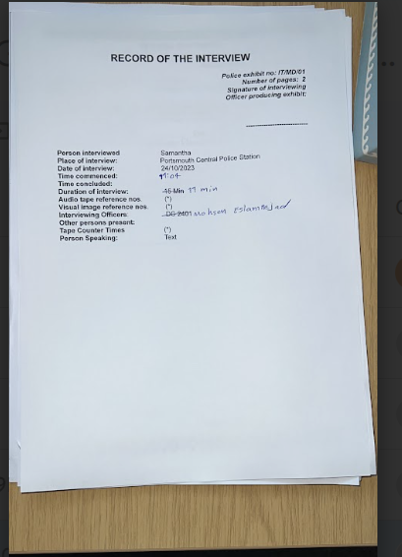

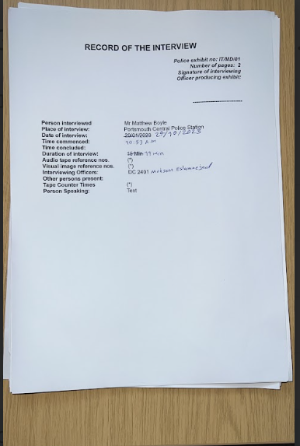

Appendix b

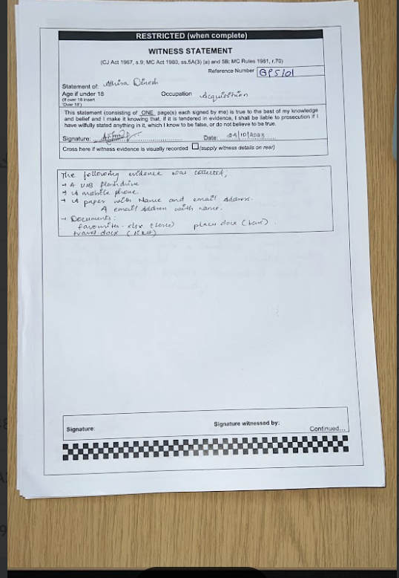

Appendix c

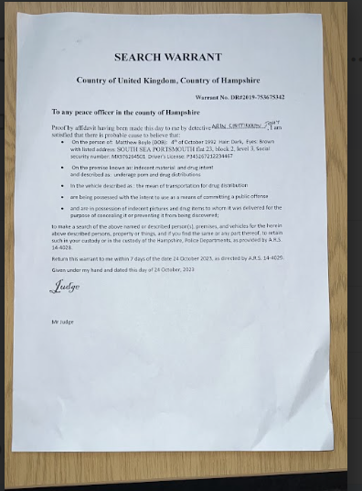

Appendix d

**Logbook for the case CP230120/BOY01 and DD230120/BOY01**

1. Acquisition of the exhibits
2. 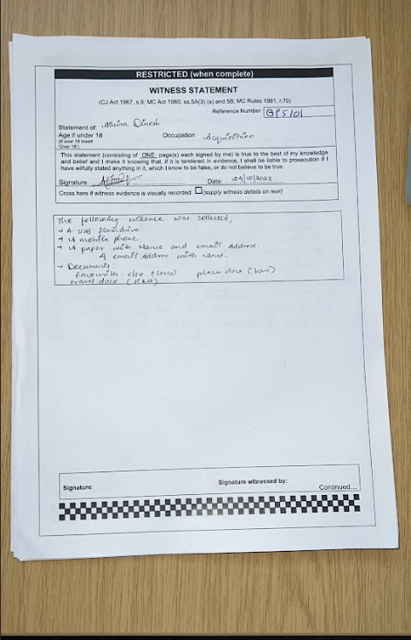

24/10/2023

The following items were received from Athira Dinesh relating to the cases of child pornograghy and drug distribution.

* a mobile phone
* documents, places.docx(bars), travel.docx(ticket), favourites.xlsx(tesco)
* USB flash drive
* a paper with a document locations,name and email written on it

1. Collection of exhibits from the evidence bag (chain of custody)

* Signature, date, etc …

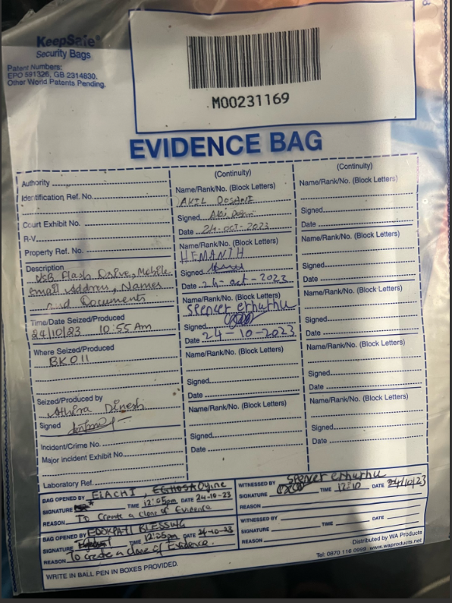

1. Imaging the exhibits:

* Process, tools

The imaging was conducted on a linux terminal. The usb drive of the suspect was inputted into the computer and all the files found on the drive were copied using a command called Clone.hd. This made an exact image of all the files so that they could be analysed without tempering with the original files.

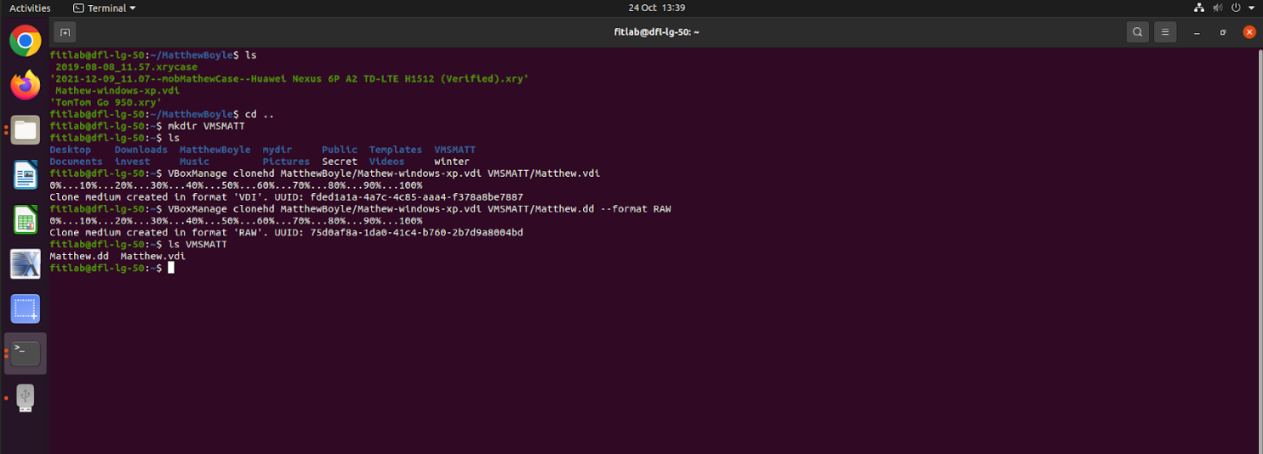

1. Preserving the evidence

* Integrity, HASH etc..

The physical evidence was kept inside an evidence bag which was concealed to prevent any tampering.

1. Analysis

* Process, tools, use of interview and police report to search for evidence

The tool used to analyse the huawei and the tom tom was XAMN. XAMN is a popular mobile forensic tool that allows someone to analyse,save and export the data within a mobile device. It is free to download and the device can be ready to analyse within seconds.

the tool. used to analyse the matthew.dd and vdi files was forensic toolkit 7.6.0. This is a software that allows for analysis of imaged devices,crack passwords,decrypt files,locate, manage and filter data.

The police report stated how Mathew was suspected of selling drugs and child pornography so any evidence relating to those charges is what was looked out for. From the analysis, Mathew had searched how to make drugs such as cocaine and how to sell them on the dark web. There were also numerous child pornography images found on the matthew.dd file.

# 